Note: Include this page only when adding / amending / deleting a document. If using this document as a record, this Revision History page can be omitted.

REVISION HISTORY

Revision no | Date | Description of Changes | Reason for Revision | Revised by | Approved by
1 | 01 June 13 | Add revision history page | - Recommendation from Stage 2 audit | RDPlacido
2 | 04 April 2014 | Excluded obsolete forms | IQA findings | WRobles
3 | Apr. 8, 2016 | Added disclaimer when printing the document | For document control | RCGanal | WRRobles
TM-BR-MG- 11 Rev02, 10302015

- Objective
To ensure that fixed assets of the company are recorded, fully accounted for and depreciation expense is properly recognized.

- Scope

This procedure defines the actions and responsibilities of AP Accountant, General Accountant and Finance Head in fixed asset management. The process begins from recording of newly acquired fixed asset to physical inventory.

- Definition of Terms

Fixed Assets Register | Is a record of fixed assets arranged chronologically. It contains the description of fixed asset, tag number, date acquired, acquisition cost, estimated useful life and depreciation.
Tag Label | Is a permanent and unique number assigned to a particular fixed asset and attached to the asset.

- Procedure Details

RESPONSIBLE | ACTIVITY |  | INTERFACE
AP Accountant |  | 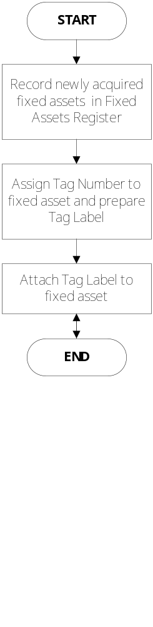 | Fixed Assets Register  Tag label

Notes:
- Issue SFARA (FO-FI-FI-04) for assets assigned to specific employee.
- Conduct physical inventory of fixed assets at least once a year.

- References
- Check voucher, invoice and delivery receipt of fixed assets

- Quality Records

- Fixed Assets Register
- Tag Label
- SFARA

